TMT/MSMantoo/S0601/2025 11-12-2025

To,
Mr. Feroz Mantoo
Company : M.S.Mantoo
Phone No :+919906510687
Mobile No :+919906510687
Email : mantooferoz@hotmail.com
City : Srinagar, State : Jammu and Kashmir

Dear sir,

Sub :- Supply of 3 ROLLER HORIZONTAL HYDRAULC PIPE BENDING MACHNE 4 INCH CAPACITY.

We are very much thankful to you for your enquiry regarding above bending machine. As requested by you we are submitting hereunder the detailed specifications
PRICE

- Three roller horizontal bending machine for bending 3-inch pipe is
RS 8,50,000(Rupees Eight Lakhs Fifty Thousand Only).

- For extra tooling the prices will be 12,000/-.

S.No | Particular | Dimension
1 | Type | Hydraulic Type Automatic
2 | Max. Dia of Pipe | 3 inch
3 | Operating Pressure | 30 kg/cm2
4 | Material for Bending | MS/GI/SS
5 | Max. Bending Radius | 180 degrees
6 | Production Rate | 180 bends/hr
7 | Voltage | 440V
8 | Motor | 3 Phase 5 hp Crompton
9 | No. of cylinders | 4

GENERAL TERMS & CONDITIONS:

- Price quoted per unit ex-work. Hyderabad.
- Following charges are additional to your account.
- Sales Tax : GST 18%
- Packing charge : As actual to be borne by you.
- Insurance : As actual to be borne by you.
- Payment : 50% advance along with order
balance before delivery but after inspection at our
works.
- Delivery : within 30 days from the date of advance.
- Validity : One month from the date of submission.
- Inspection : Inspection at our works prior to dispatch.
7 Warranty : The machine is warranted for a period of 12
months from the date of dispatch against any
manufacturing defects/faulty material or bad
workmanship of any part or component but not
against any kind of abnormal or improper use of
machine. Defective part or component will be
replaced or repaired free of cost. Electrical
components are outside the scope of this
warranty.
- Commissioning : Erection & commissioning done by you, but if
required technical support & guidance provide by
us at additional cost.
NOTE:

- Oil is not in scope of our supply.
- Raw material for trial is arranged by you at your cost.

We are sure you will find our offer in line with your requirements. Should you require any further clarification please call us on mobile number 9246221106.email: info@technomachinetools.in

Thanking you and assuring you of our best services.

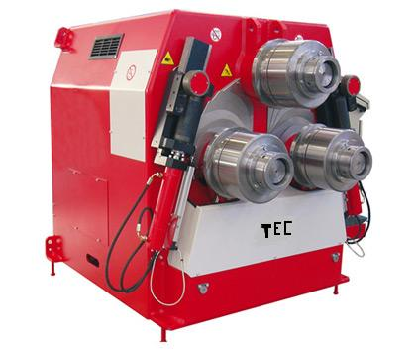

For TECHNO MACHINE TOOLS

( T. SIVARAMAKRISHNA)

